**Instructions for Power**

Before you use power to create a new file:

* Go to: settings > storage > other apps > power
* Press clear storage

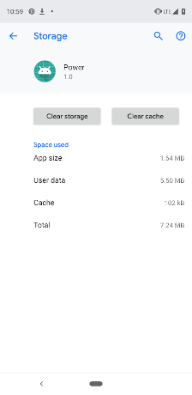

* Open Power
* Allow permissions
* From the home screen swipe up

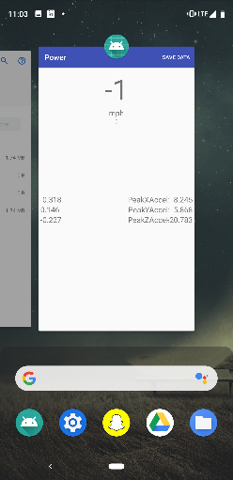

* Swipe the preview for Power up ---- need to do this otherwise mph will never update
* Open Power again
* -the app will now start recording-
* Press save when done

To Find File on Phone:

* Go to settings > storage > files

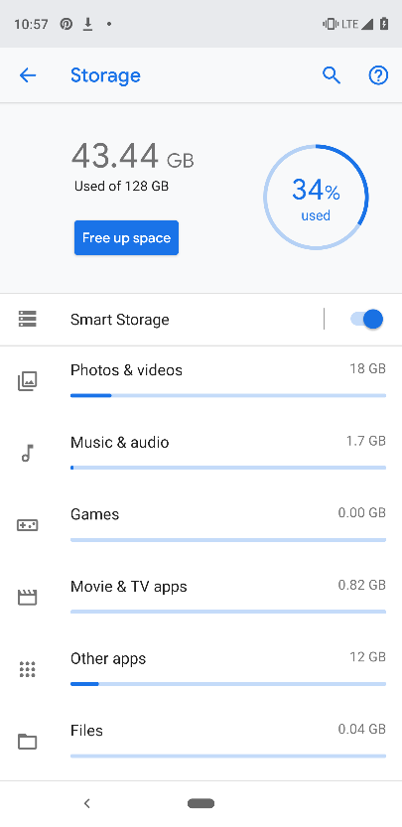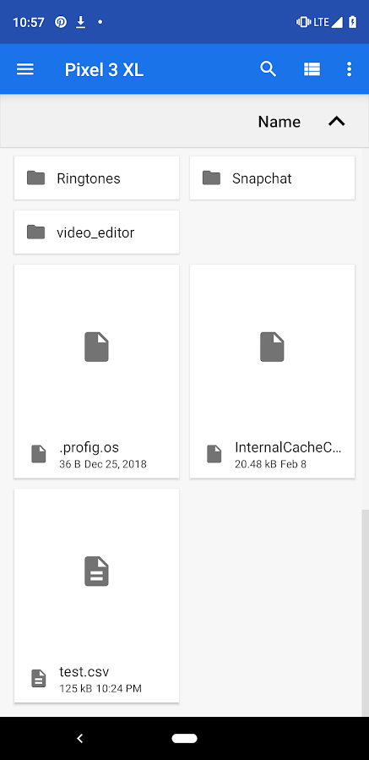

* Add test.csv to drive

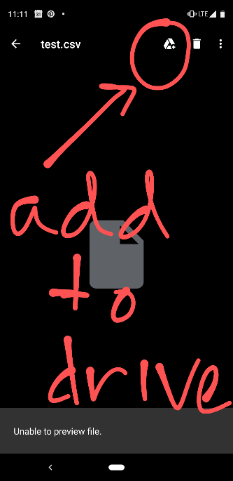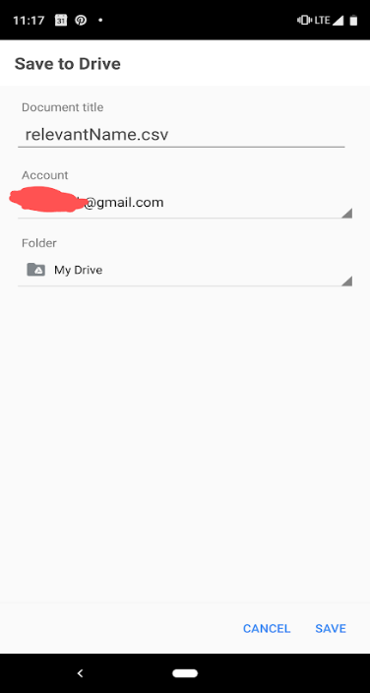

* Change filename test.csv to something relevant and save